Hội nghị Sinh viên Nghiên cứu khoa học Khoa Đào Tạo Quốc Tế năm học 2025-2026 (Lần IV)
Ứng dụng trí tuệ nhân tạo trong hỗ trợ di chuyển an toàn cho người khiếm thị: Đề xuất hệ thống SafeVision
Artificial Intelligence Application for Safe Navigation of the Visually Impaired: Proposing the SafeVision System
Trung-Kien Dangª, Tien-Dat Tranª, Thi-Thu-Anh Nguyenª, Trung-Kien Nguyenª, Minh-Tien Huynhª
ªInternational School, Duy Tan University, Da Nang 550000, Vietnam
GVHD: ThS. Lê Văn Tịnhª
Abstract
In the context of rapid urbanization in Vietnam, the transportation infrastructure is becoming increasingly complex, posing numerous risks to vulnerable populations, particularly the visually impaired. Traditional navigation aids, such as the white cane, exhibit significant limitations regarding detection range and warning space, whereas imported technological solutions are prohibitively expensive and rely on training data incompatible with domestic traffic characteristics. To address this issue, this research proposes and develops SafeVision, a mobile application leveraging Deep Learning and Computer Vision to assist visually impaired individuals with real-time object detection. The system utilizes the YOLO architecture (specifically YOLOv8), optimized via the TFLite format for on-device inference on mid-range mobile devices, thereby eliminating heavy reliance on cloud servers. Integrated with Google's Text-to-Speech (TTS) technology, SafeVision analyzes the video stream from the smartphone camera, identifies common street objects (motorcycles, cars, pedestrians, obstacles), and outputs natural Vietnamese voice alerts. Empirical results in the Da Nang area indicate that the model achieves a processing speed of over 15 FPS and a highly promising mean Average Precision (mAP). The application not only enhances independent mobility and supports indoor daily activities but also carries profound humanitarian significance, facilitating the seamless integration of the visually impaired community into the digital society.
Từ khóa: SafeVision; Visually Impaired; Object Detection; Deep Learning; YOLOv8; Mobile Application; Text-to-Speech.
Content
- Problem Statement
  - Research Background
Currently, visually impaired and low-vision individuals constitute a significant proportion of the population in Vietnam. For them, independent navigation for daily living, education, and employment is a fundamental necessity yet fraught with challenges. The specific characteristics of traffic and urban infrastructure in Vietnam are exceedingly complex: heavy motorcycle traffic, sidewalks frequently encroached upon by street vendors, and unexpected obstacles such as low-hanging signs, damaged manhole covers, or illegally parked vehicles are ubiquitous. This creates a navigation environment fraught with latent risks and potential accidents for the visually impaired.
  - Limitations of Existing Solutions
Traditional assistive tools like the white cane can only detect low-level obstacles within a very close physical proximity (1 to 1.5 meters) and are entirely ineffective against head-level obstacles or fast-moving vehicles. Globally, several technological devices and applications assist the visually impaired, such as OrCam smart glasses, Microsoft's Seeing AI, or Google Lookout. However, these solutions face two major barriers when deployed in Vietnam:
First, the cost of specialized hardware is prohibitively high relative to the income of the vast majority of domestic users.
Second, the Artificial Intelligence (AI) models of these imported applications are typically trained on Western datasets; thus, they prove inefficient and inaccurate when detecting Vietnam-specific objects (e.g., overloaded motorcycles, street food stalls, conical hats, raincoats). Furthermore, no application genuinely supports offline execution without an Internet connection. Although most individuals now own smartphones with 4G mobile data, a consistently stable network connection during transit cannot be guaranteed.
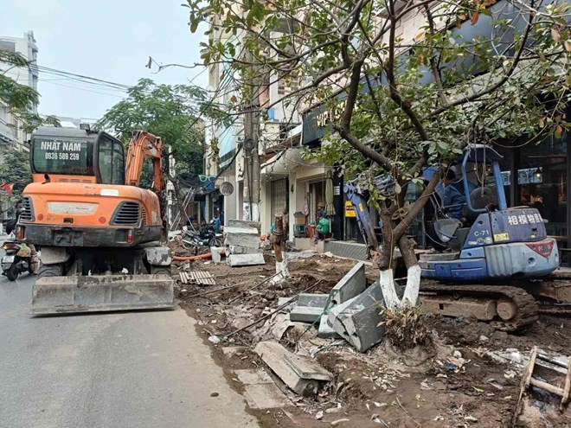
Figure 1: Image of a road under construction in Vietnam
Based on current mobile software technologies and popular specialized devices, while support for the visually impaired is generally strong, applying these technologies to the Vietnamese environmental context exposes distinct flaws, directly impeding users' situational awareness.
Table 1.1: Comparison of prevailing specialized technologies and devices for the visually impaired
Specialized Device / Solution | Core Technology | Estimated Cost | Limitations
Traditional White Cane | Basic mechanics, reflective design. | Very low (tens to hundreds of thousands VND) | Low-level, close-range detection only. Ineffective against head-level obstacles or fast-moving vehicles.
Smart Cane | Ultrasonic sensors, haptic feedback, microcontrollers. | Medium to high (15 to 38 million VND). | Limited sensor scanning range. Only alerts presence, lacks classification/identification (e.g., motorcycle vs. manhole).
High-end Smart Glasses (OrCam MyEye / Envision) | Wearables with integrated AI, Computer Vision. | Extremely expensive (90 to 115 million VND). | Exceeds affordability for most users. Training data mostly Western, ineffective for complex Vietnamese traffic.
Mobile Apps (Seeing AI / Google Lookout) | Trí tuệ nhân tạo Artificial Intelligence (AI), Cloud Computing. | Free | Strictly dependent on network connectivity (WiFi/4G), causing high latency. Not optimized for Vietnamese urban infrastructure.

  - Proposing SafeVision
Recognizing that Android smartphones are becoming increasingly ubiquitous and accessible even to low-to-middle-income demographics, the research team initiated the development of the "SafeVision" project. The core objective of SafeVision is to leverage the computational power of modern smartphones, coupled with state-of-the-art Computer Vision algorithms (YOLOv8), to transform the mobile device into a "digital eye" for the user. The application scans the surrounding environment via the camera, performs on-device processing of image data to minimize latency, and provides Vietnamese audio alerts and navigation cues. SafeVision's hallmark is its "exclusive" support for Vietnamese users, prioritizing accurate localized recognition followed by direct user alerts. SafeVision aspires to bridge the current technological gap, delivering a reliable, low-cost, and fully localized virtual assistant for the visually impaired in Vietnam.
- Research Methodology
  - Overview of the Research Landscape
The proliferation of Convolutional Neural Networks (CNNs) has fundamentally revolutionized the domain of Object Detection. Among them, the YOLO (You Only Look Once) algorithm family developed by Ultralytics has demonstrated absolute superiority in balancing accuracy and real-time processing speed. Recently, numerous global studies have begun applying YOLO to visually impaired assistance systems, combining it with proximity sensors (such as ultrasonic on Arduino/ESP32) to create obstacle-warning wearables or smart glasses. In Vietnam, several student cohorts have also developed AI-integrated smart cane projects. However, the majority of these projects rely on network connectivity to offload image processing to servers, resulting in high latency and rendering them inoperable in areas with poor signal coverage.
  - Approach and Technology Stack Selection
To mitigate the latency issue, the team implemented an Edge AI methodology for on-device processing. The primary technologies selected include:
- Core Algorithm: YOLOv8 Deep Learning model (nano/tiny versions). This selection is predicated on the model's ultra-compact footprint and its capability to predict objects with high precision in a single forward pass, which is highly optimal for smartphone hardware constraints.
- Model Processing and Optimization: Utilizing Python and PyTorch for model training. Subsequently, Quantization and Pruning techniques are applied to export the model into the .tflite (TensorFlow Lite) format, significantly reducing memory footprint and power consumption.
- Mobile Application Development (Frontend): Utilizing the Flutter framework for UI implementation. Flutter facilitates seamless camera stream integration and highly customizable UI/UX specifically tailored for the visually impaired (minimalist interface, full-screen swipe/touch gestures).
- Audio Processing: Integrating Google Text-to-Speech (TTS) API to synthesize natural language, articulating object classifications and estimated proximities in Vietnamese.
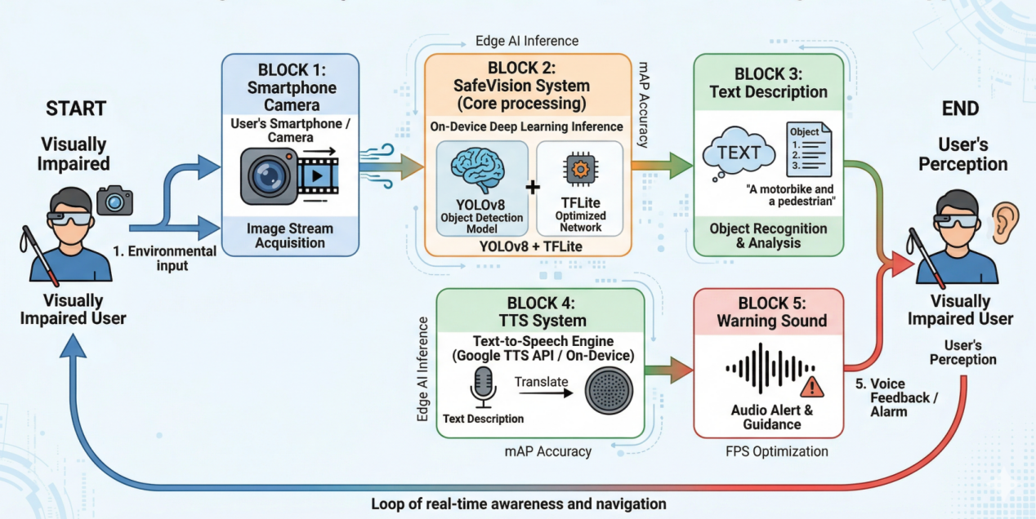
Figure 2: SafeVision system architecture diagram
  - Data Collection and Processing Pipeline
This is the most critical phase dictating the success of SafeVision. As utilizing Western datasets was unfeasible, the team constructed a completely novel, localized dataset.
- Data Acquisition: The team recorded videos and captured images navigating through complex streets and sidewalks in Da Nang city across various timeframes and lighting conditions (morning, noon, afternoon, night, and rainy weather).
- Data Cleansing and Augmentation: Applying cropping, rotation, brightness, and contrast adjustments to enrich the dataset, enabling the model to generalize across environmental variances.
- Data Labeling: Utilizing LabelImg and RoboFlow tools to draw bounding boxes and annotate thousands of images. Target classes encompass: Moving motorcycles, Parked motorcycles on sidewalks, Cars, Pedestrians, Stone benches, Manhole covers, Bus stops, and Low-hanging signs.
  - Agile/Scrum Project Management Framework
Comprising 5 members (Scrum Master: Dang Trung Kien; AI Engineers: Nguyen Trung Kien, Dang Trung Kien; Data/Testers: Nguyen Thi Thu Anh, Huynh Minh Tien; Mobile Dev: Tran Tien Dat), the project rigorously adhered to the Agile/Scrum framework to control progress over a 5-month lifecycle (10/2025 - 04/2026). The project was segmented into 5 Sprints. Implementing Scrum enabled continuous evaluation of the AI model's performance post-iteration, allowing for prompt hyperparameter tuning without disrupting mobile UI/UX development.
- Research Results
  - AI Model Training Results
The YOLOv8n model was trained on a Cloud GPU environment (Google Colab Pro) for 50 epochs with an image size (imgsz) of 640x640. The training process demonstrated excellent algorithmic convergence:
- The model's loss function decreased rapidly within the initial 50 epochs and maintained steady improvement until the culmination of the training process.
- The mAP50 metric (Mean Average Precision at an IoU threshold of 0.5) averaged over 88% across most object classes.
- The original .pt format, weighing approximately 11-12MB, was quantized into .tflite, condensing the size to roughly 3-4MB, facilitating direct integration into the application's source code.
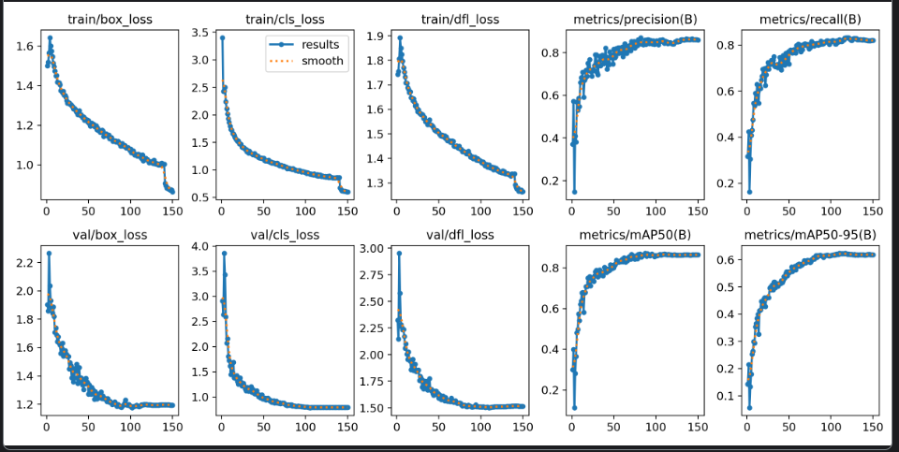
Figure 3: AI training results with the Vietnamese environment dataset
  - Empirical Performance on Mobile Devices
Upon deploying the model to mid-range Android devices, field testing results on the streets of Da Nang were highly positive:
- Frame Rate (FPS): Ranged from 15 to 22 FPS depending on hardware specifications. This throughput adequately satisfies the requirement for smooth video stream analysis, providing near-zero latency (real-time) alerts to navigating users.
- Exception Handling: The system operates optimally under daylight conditions. Under low-light or backlit conditions, the detection rate experiences a marginal decline (approximately 15-20%) but retains the capability to detect large-scale objects.
  - SafeVision Application Features
The final deliverable is a standalone installable APK file. The application is architected following the "Accessibility First" principle:
- User Interface (UI/UX): The interface is highly minimalist, employing ultra-high contrast color blocks (catering to low-vision users who retain light perception). Navigation relies on full-screen swipe and multi-touch gestures rather than precise small-button interactions.
- Voice Feedback Mechanism: Integrates intelligent filtering algorithms to prevent overlapping alerts and user cognitive overload. The system only triggers audio feedback for obstacles entering the risk zone (areas occupying over 30% of the camera frame).
- Auxiliary Features: An indoor object-finding mode (scanning the environment to locate tables, chairs, water cups) and a tutorial mode to acclimate new users to the notification system.
- Discussion
The SafeVision application successfully addresses the core initial challenges: real-time processing, low cost (software deployed on personal smartphones), and suitability for the Vietnamese traffic context. Compared to traditional methods like the white cane, SafeVision provides an extended "vision" range of 3 to 5 meters, granting users sufficient reaction time to evade hazards. Compared to foreign applications with similar functionalities, SafeVision excels in accurately detecting complex objects on Vietnamese sidewalks due to meticulous dataset curation.
Nevertheless, the study also highlights several limitations requiring mitigation. Continuous camera processing and AI inference consume significant hardware resources, leading to thermal throttling and substantial battery depletion if utilized continuously for over 2 hours. Additionally, hand-holding the device during transit induces motion blur, occasionally degrading the AI's inference accuracy. A proposed future mitigation involves designing mounting clips to affix the smartphone to the user's chest or hat, ensuring frame stabilization and hands-free operation.
- Conclusion
  - Achieved Results
The "SafeVision" research has validated the immense potential of deploying Deep Learning algorithms (YOLOv8) directly on edge mobile devices. The research team successfully engineered a localized dataset, trained and optimized the neural network, and deployed a fully functional mobile application capable of obstacle detection and Vietnamese voice alerts. SafeVision transcends being merely a software engineering project; it is a profoundly humanitarian product. This tool serves as a dedicated "digital eye," assisting the visually impaired in overcoming physical limitations, mitigating injury risks from traffic accidents, and incrementally helping them regain the confidence to actively participate in community life.
  - Future Development Directions
Building upon the robust current technical foundation, the research team outlines several developmental trajectories for subsequent iterations:
- GPS-Integrated Navigation: Incorporating mapping and Location-Based Services (LBS) to not only warn of obstacles but also guide visually impaired pedestrians from point A to point B via the safest routing.
- Algorithmic Enhancements in Adverse Weather: Integrating image filters to denoise inputs affected by rain or fog; expanding the dataset with nocturnal imagery.
- Familiar Face Recognition: Identifying acquaintances within groups (relatives, friends, known individuals) and triggering audio feedback identifying the person, facilitating easy social recognition.
- Emergency Contact Integration: Determining the user's real-time status and dispatching emergency distress signals containing the user's condition and location to pre-selected emergency contacts when danger is detected.
Tài liệu tham khảo
- LeCun, Y., Bengio, Y., & Hinton, G. (2015). Deep learning. Nature, 521(7553), 436-444. https://doi.org/10.1038/nature14539
- Wang, J., et al. (2024). YOLO-OD: Obstacle Detection for Visually Impaired Navigation Assistance. Sensors (MDPI), 24(23), 7621. https://doi.org/10.3390/s24237621
- Sharma, A., et al. (2025). Wearable Navigation Aid for Visually Impaired People Using AI. International Journal of Scientific Research and Archive, 33(72), 112-120. https://ijsra.net/sites/default/files/fulltext_pdf/IJSRA-2025-3372.pdf
- IEEE. (2025). Artificial Vision – Yolov8 Algorithm for Objects and Impediments Detection. IEEE Xplore Conference Publication, 10895298. https://ieeexplore.ieee.org/document/10895298/
- IJSEA. (2024). YOLO-Based Object Recognition System for Visually Impaired. International Journal of Science and Engineering Applications, 14(1), 09-15. https://ijsea.com/archive/volume14/issue1/IJSEA14011009.pdf
- Amidi, S., & Amidi, A. (2018). CS 230 - Mạng nơ ron tích chập cheatsheet. Stanford University. https://stanford.edu/~shervine/l/vi/teaching/cs-230/cheatsheet-convolutional-neural-networks
- Ultralytics. (2024). Tài liệu Ultralytics YOLO. Ultralytics. https://docs.ultralytics.com/vi/
- Google Cloud. (2024). Tạo lời nói từ văn bản (Google Cloud Text-to-Speech API). Google. https://cloud.google.com/text-to-speech/docs
- Microsoft. (2024). Seeing AI: An app for visually impaired people that narrates the world around you. Microsoft Garage. https://www.microsoft.com/en-us/garage/wall-of-fame/seeing-ai/
- Scrum.org. (2024). What is Scrum?. Scrum.org. https://www.scrum.org/resources/what-is-scrum

